**Course: Advance Bio Informatics**

**Module Title: Steps for Natural Language Processing**

**Module No: 96**

**Steps for NLP**

Sentence boundary

Lexicalization (tokenization)

Function Words removal

Content Words

POS tags

Parse tree/ syntax tree

NER

Co-reference resolution

Stemmer

Lemmatization

**Steps for NLP**

**General Framework of NLP (John runs.)**

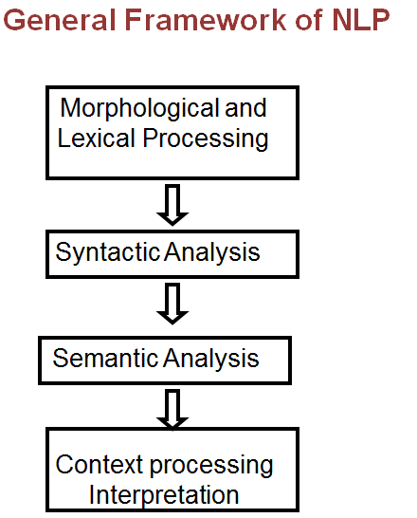

**Steps for NLP**

